**BEETLE GAME REPORT**, part 2

By …

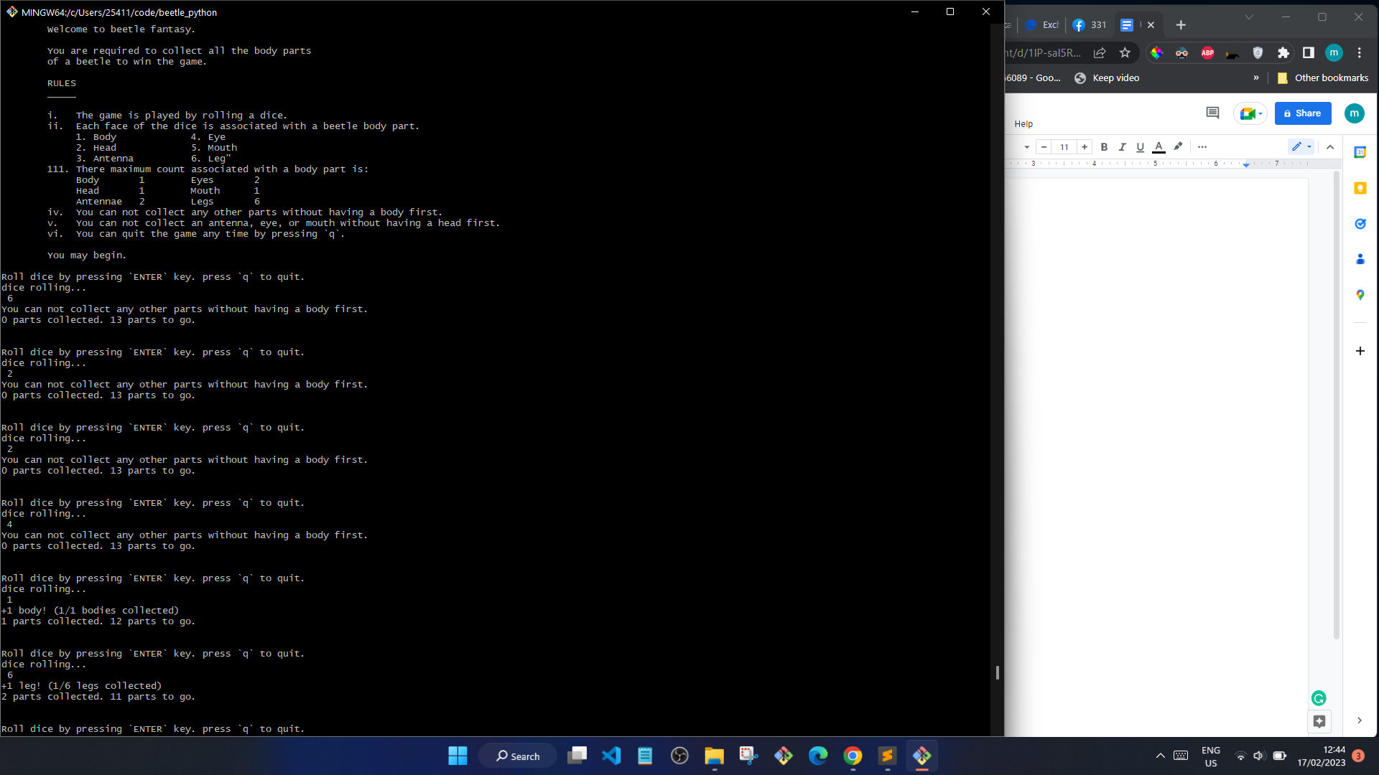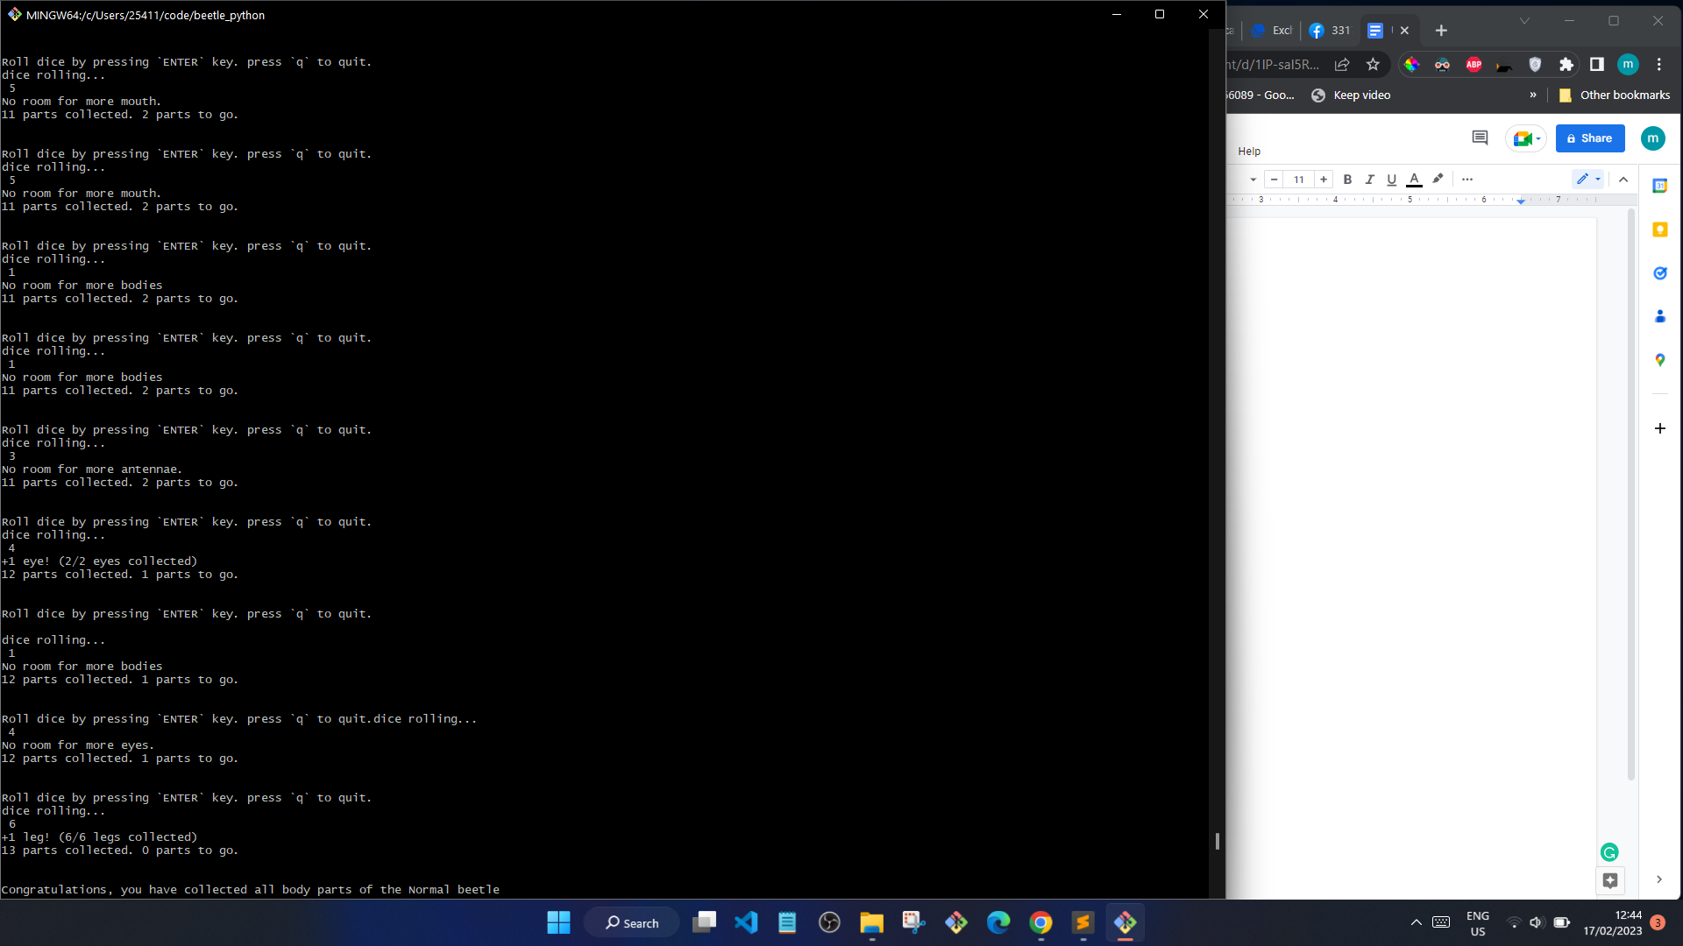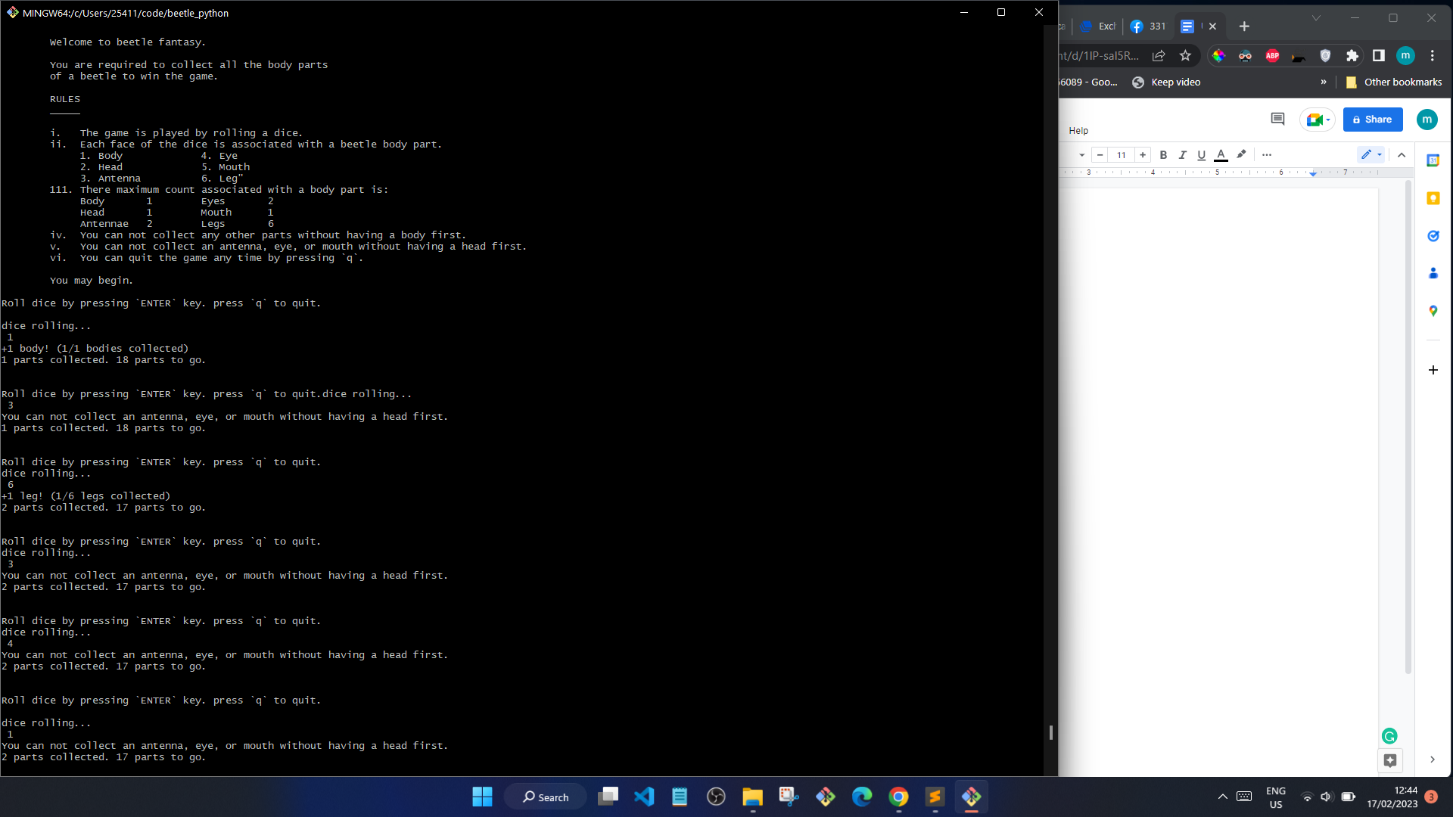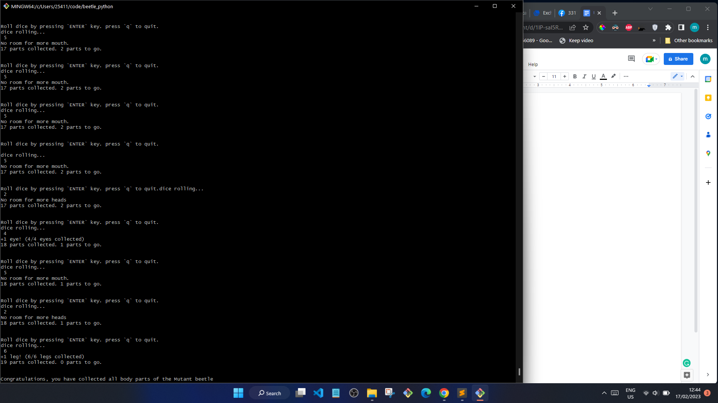

The counts added were:

* Tallies (int array) - The number of times each body part was ‘selected’. This includes the times that the body part could not be added. This variable is crucial as it can be used to observe the probabilities in a random space. It also helps compare the difference between a normal and mutant beetle.
* Rejected_because_incomplete (int) - This variable collects the times it takes to get a head and a body. With this variable, we can know how many rolls it takes to ‘break even’ for both beetles.
* Rolls (int) - This variable was used to show the number of rolls needed to get a complete beetle (normal and mutant).

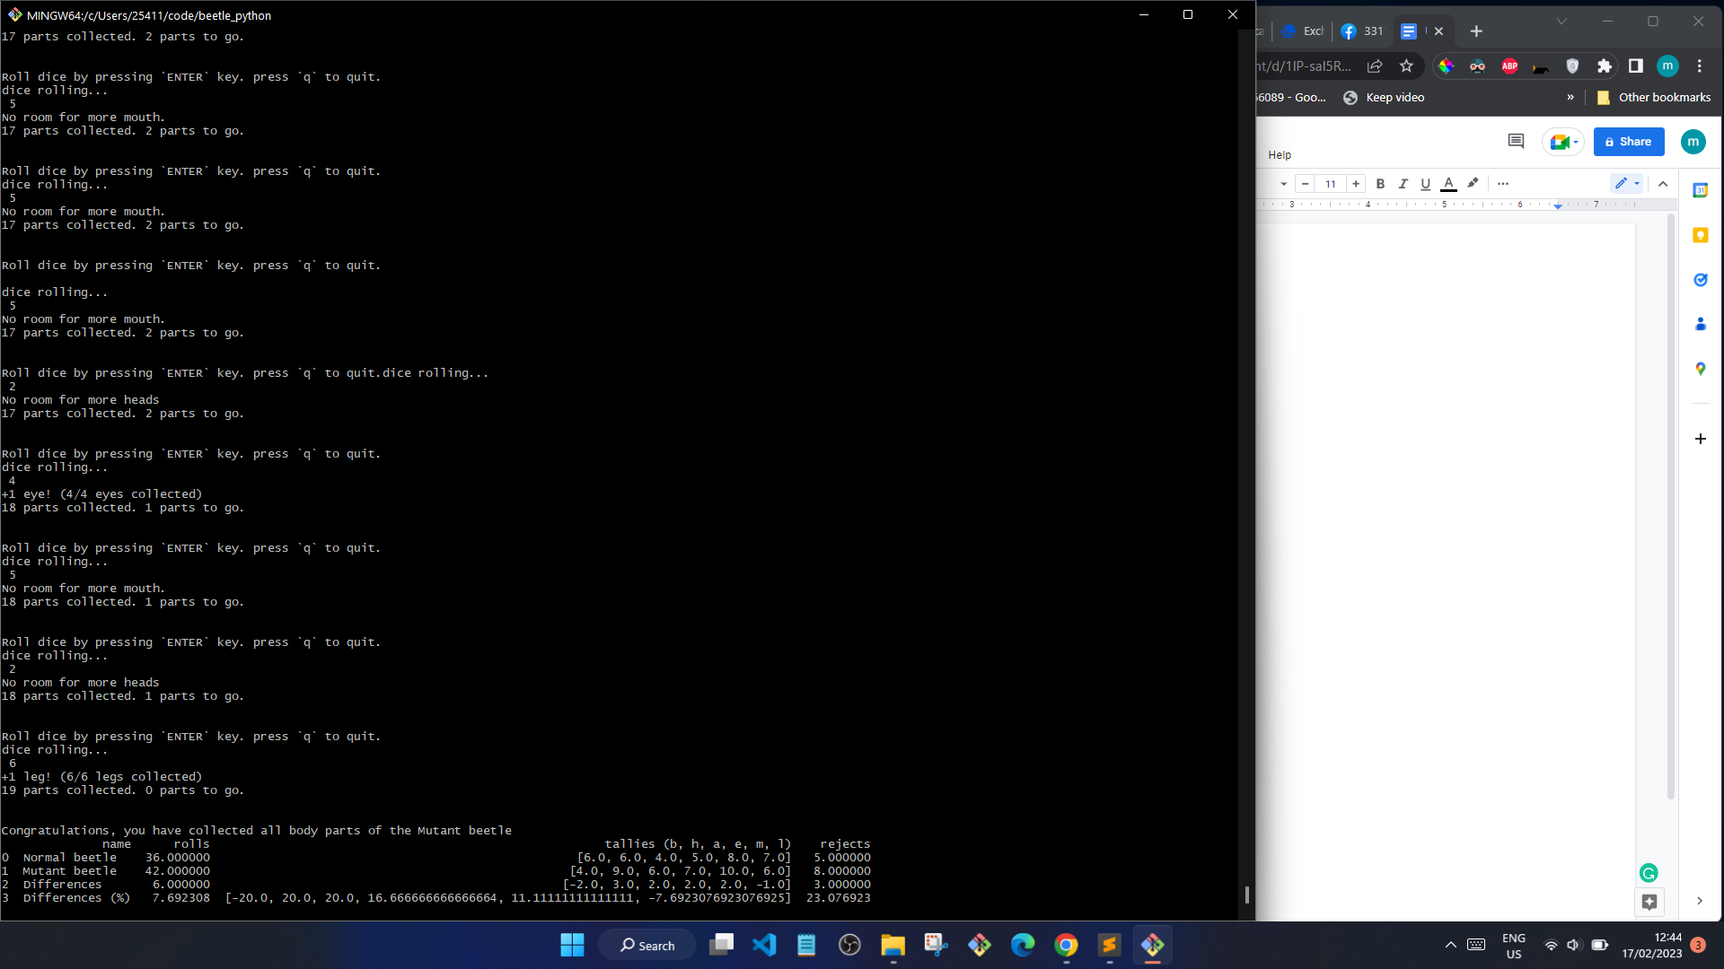

From the counts collected above, the following conclusions can be drawn:

1. It takes an average of 6 more rolls to get a complete mutant beetle than it takes to get a complete normal beetle.
2. For a mutant beetle, it takes an average of 3 more rolls to get the core parts of its body (heads and body).
3. The average body part is collected 6 times in normal beetles, with a standard deviation of 1.29
4. The average body part is collected 7 times in mutant beetles, with a standard deviation of 2